SIMATS ENGINEERING

Department of ComputerScience and Engineering

ASSESSMENT TOOL2 - CONCEPT MAPPING
NAME:YAZHINI.E.M
REG NO:192511165

Concept Maps: CPU Execution Cycle & Performance, and 8085 vs 8086 Architecture
Computer Organization and Architecture — Assignment

QUESTION 1: Instruction Execution Cycle and CPU Performance Parameters
Every instruction a processor executes passes through the fetch–decode–execute cycle. This cycle is the fundamental engine of program execution, and the time it takes to complete determines overall CPU performance. The concept map below links each stage of the cycle to the quantitative parameters — clock cycles, CPI, and execution time — used to measure that performance, and shows how memory access, instruction complexity, and pipeline stalls act as the real-world factors that push these parameters up or down.
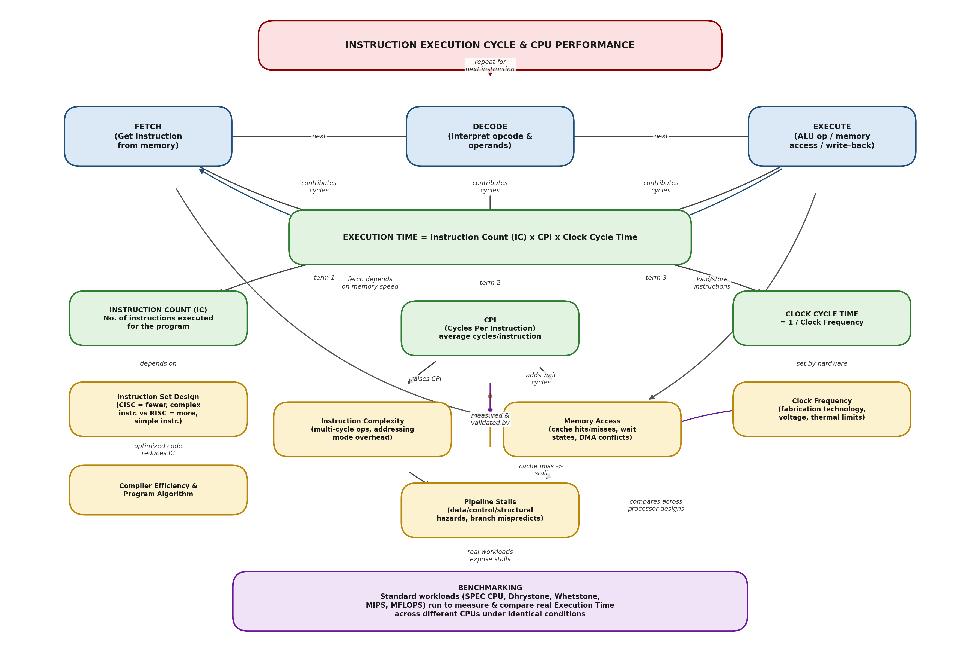
Figure 1: Concept map linking the fetch–decode–execute cycle to CPI, clock cycles, execution time, and benchmarking

1.1 The Fetch–Decode–Execute Cycle
- Fetch: The CPU reads the next instruction from memory into the instruction register, using the Program Counter (PC) to know its address. This stage's speed is tied directly to memory access time.
- Decode: The control unit interprets the opcode, identifies the operands, and determines which addressing mode and functional unit are needed. More complex instructions require more decode logic and cycles.
- Execute: The ALU performs the operation, a memory read/write occurs if needed, and results are written back to a register. This stage may itself trigger a memory access (for load/store instructions).
These three stages repeat for every instruction, forming a continuous cycle. In a pipelined CPU, several instructions occupy the fetch, decode, and execute stages simultaneously (each at a different stage), which is what allows one instruction to complete, on average, in far fewer than three full cycles.

1.2 Core Performance Equation
The single equation that ties the whole concept map together is:
Execution Time = Instruction Count (IC) × CPI × Clock Cycle Time
- Instruction Count (IC): The total number of machine instructions the program executes. A CISC processor (like the 8086) often needs fewer, more powerful instructions to do the same job than a RISC processor.
- CPI: Cycles Per Instruction — the average number of clock cycles each instruction takes to complete, including any extra cycles lost to stalls or memory waits.
- Clock Cycle Time: The duration of one clock pulse, equal to 1 ⁄ (clock frequency). It is set mainly by the fabrication technology, operating voltage, and thermal design of the chip.
Because Execution Time is a product of all three terms, improving any one of them — writing more efficient code (lower IC), reducing stalls and simplifying operations (lower CPI), or using faster silicon (shorter cycle time) — reduces total execution time.

1.3 Factors That Push CPI Up or Down
- Instruction Complexity: Instructions that need multiple micro-operations (e.g., multiply, divide, or instructions using indirect/indexed addressing) take more clock cycles than simple register-to-register operations, directly raising CPI.
- Memory Access: A cache hit costs very little, but a cache miss forces the CPU to wait many cycles for data from main memory. Since the fetch stage reads instructions and the execute stage may read/write operands, memory latency directly inflates the effective CPI.
- Pipeline Stalls: In a pipelined design, data hazards (an instruction needs a result not yet ready), control hazards (branches whose target isn't known yet), and structural hazards (two instructions needing the same hardware unit) force the pipeline to insert bubbles/stalls, which increase the effective CPI above its ideal value.

1.4 Benchmarking
Because execution time depends on IC, CPI, and clock cycle time together, comparing two processors fairly cannot be done from a datasheet clock speed alone. Benchmarking runs standardized workloads — such as SPEC CPU, Dhrystone, and Whetstone, or reports results as MIPS (Million Instructions Per Second) and MFLOPS (Million Floating-Point Operations Per Second) — on real hardware and measures the actual execution time. This exposes real effects of instruction complexity, memory hierarchy, and pipeline stalls that a theoretical calculation might miss, giving a realistic, comparable measure of performance across different CPU designs.

QUESTION 2: 8085 vs 8086 Architecture Comparison
The Intel 8085 (an 8-bit microprocessor) and the Intel 8086 (a 16-bit microprocessor) represent two generations of x86-lineage design. Their differences in instruction set, register organization, addressing modes, and memory handling are not just technical trivia — each difference directly shapes how efficiently a program runs, how many tasks the processor can handle at once, and how suitable the chip is for real-time embedded control versus general-purpose computing.
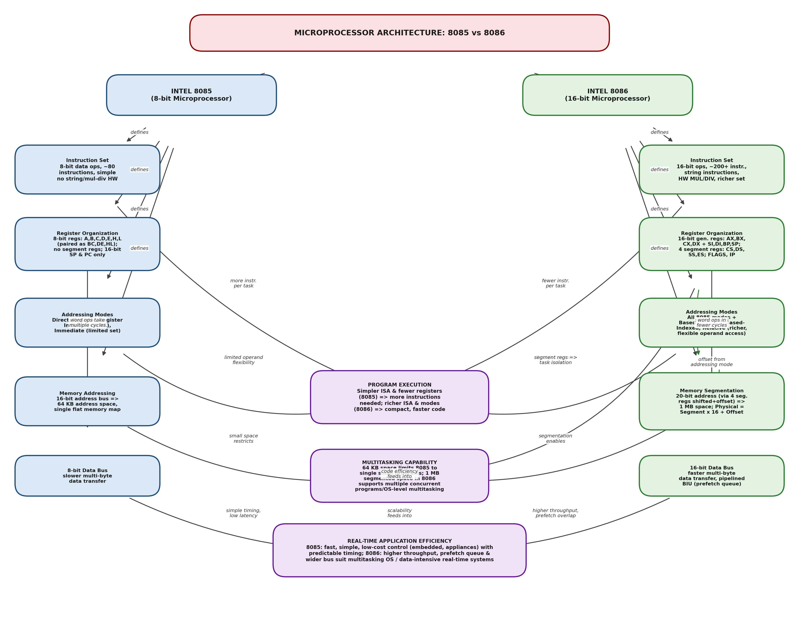
Figure 2: Concept map comparing 8085 and 8086 architecture and its impact on execution, multitasking, and real-time efficiency

2.1 Side-by-Side Feature Comparison
Feature | Intel 8085 (8-bit) | Intel 8086 (16-bit)
Data bus width | 8-bit | 16-bit
Address bus / memory space | 16-bit → 64 KB | 20-bit (segmented) → 1 MB
Instruction set | ~80 instructions; simple, no hardware multiply/divide, no string instructions | 200+ instructions; hardware MUL/DIV, string instructions (MOVS, CMPS, etc.), richer instruction repertoire
General registers | 8-bit: A, B, C, D, E, H, L (pairable as BC, DE, HL) | 16-bit: AX, BX, CX, DX, plus SI, DI, BP, SP
Special registers | Program Counter, Stack Pointer, Flag register (no segment registers) | IP (Instruction Pointer), FLAGS, and four segment registers: CS, DS, SS, ES
Addressing modes | Direct, register, register-indirect (via HL pair), immediate | All 8085-style modes plus based, indexed, based-indexed, and relative addressing
Memory organization | Single flat 64 KB address space | Segmented memory: Physical Address = Segment × 16 + Offset, giving 1 MB from four 64 KB segments
Internal design | Simple single-unit fetch–execute, no instruction prefetch | Split into Bus Interface Unit (BIU) and Execution Unit (EU) with an instruction prefetch queue, allowing fetch and execute to overlap

2.2 Why These Differences Matter
- Program Execution Efficiency: The 8085's smaller, simpler instruction set and limited addressing modes mean a compiler or programmer often needs more instructions to express the same task, raising the Instruction Count (IC) in the execution-time equation. The 8086's richer instruction set and flexible addressing modes (based, indexed, based-indexed) let one instruction do more work — for example, accessing an array element directly with a single based-indexed instruction rather than several 8085 instructions — producing more compact, faster-executing code.
- Multitasking Capability: The 8085's 64 KB address space, with no hardware support for separating code, data, and stack, forces all programs and data to share one small, undifferentiated memory area — impractical for running several independent programs safely at once. The 8086's segmentation scheme uses CS, DS, SS, and ES to give each program logically separate code, data, and stack areas within a 1 MB space; combined with its wider register set, this laid the groundwork for the multitasking and memory-protection features that later 80x86 processors (and DOS/early Windows) relied on.
- Real-Time Application Efficiency: The 8085's simplicity — few registers, a small instruction set, no prefetch queue — gives short, highly predictable instruction timing, which suits low-cost, deterministic embedded control (appliance controllers, simple I/O control) where real-time predictability matters more than raw throughput. The 8086's overlapped fetch/execute (via the BIU and prefetch queue), 16-bit data path, and larger addressable memory give it much higher throughput, making it (and its successors) better suited to real-time systems that must process larger data sets or run several time-critical tasks together, at the cost of more complex, less uniform instruction timing.
In short, every architectural upgrade from the 8085 to the 8086 — wider registers, a larger and more flexible instruction set, additional addressing modes, and segmented memory — reduces the number of instructions and cycles needed per task while extending the usable memory space, which is precisely why the 8086 could support more capable operating systems and heavier real-time workloads, while the 8085 remained better suited to small, single-purpose, time-deterministic control applications.

